MY PORTFOLIO
Introduction:
This portfolio tries to demonstrate how I have put my various skills into use in making wonderful web apps that have cast a smile on my clients' faces. In the course of this write-up, I will be showing how I pulled off such tasks and the various skills I employed. I hope after going through my portfolio you would have convincing reasons why we should work together.
Bios:
Name: Oken Chinonso Livinus
Description: A full-stack web developer with over 5 years of experience
Phone: +234 8162750411
Email: okenchinonsolivinus2@gmail.com
LinkedIn: https://www.linkedin.com/in/chinonso-oken-94bb29153
GitHub: https://github.com/Oken/web-design
Design Principle: If you are going to do it, do it well.
Projects:
Project One:
Title: FECAMDS DINNER TICKETING
Description: To cut down expenses, the Federation of Catholic Medical and Dental Students (FECAMDS) in Obafemi Awolowo University (OAU), Nigeria decided to do something different for their annual dinner night. They opted in for an online ticketing, where they could process and print out their tickets.
Each ticket was to be unique with the name of each student printed on it with their unique identification number. This was one of the greatest challenge encountered in doing the project. The second challenge was that the association had no money for a hosting service where the built app would be deployed. The time was also very short
Link: https://fecamds-dinner.web.app
Technologies Used: HTML, CSS, JavaScript, Firebase, Firestore, Adobe Illustrator, jQuery and jsPDF libraries
My Contributions: I was the sole developer who built out the app. After planning and prototyping, I successfully completed the project. How? First I designed the raw format of the ticket using Adobe Illustrator with spaces where the unique names and ID would be.
Using HTML, CSS and JavaScript I created an interactive beautiful UI which had images from the association's last outdoor meeting forming the carousel of the hero section and the main part of the homepage. Sign-up and login pages were also built and had user interactivity on them.
For the dashboard, where the tickets were to be printed out from, the initial plan was to use PHP. However, this could not be used since the association could only afford a free hosting service. Therefore, I opted in for Google Firebase, where the website was eventually deployed. Using Google Firestore, a non-SQL database system, I stored the various data needed to login the user and update their tickets should they want to print them.

Making the ticket unique was the most daunting of it all. However, I knew I could do it, and hence, why I picked up the project. Using HTML canvas and a bit of JavaScript, I positioned the unique details on the raw format ticket. Using the unique API provided by the HTML canvas and blob file, I made an option that allows the students to print the ticket as an image. Also, using jsPDF library, I provided a button where the PDF format of the ticket could also be downloaded.
The dashboard has a logout button too. The app is so unique that no two persons can have the same ID on their ticket and no one can use a fake ID.
Project Two:
Title: ASPECT BLOCKCHAIN
Description: A US-based company which sells, hosts and maintains bitcoin hashing engines, contacted me to build a site for them. They already had a backend developer and I was to make the frontend, including the UI elements of the dashboard. The course of the project was very long. The company was a new startup. They kept on changing their ideologies over and over again.
The major challenge was that the client wanted me to make a feature on the app dashboard functional. That feature was to enable a user 'Add Pool Account' and be able to see the pools of choice reflected on their dashboard. The problem here was that it was supposed to be the work of the backend to process the data the user fills in the 'Add Pool Account' form and store it on the database. It was also his responsibility to ensure that the dashboard displays the pools of choice to each user.

Links:
- Homepage - https://oken.github.io/Web-Design/project-oken1
- Dashboard - https://oken.github.io/Web-Design/project-oken1/dashboard/hosting-order.html
Technologies Used: HTML, CSS, JavaScript and Bootstrap CSS & JS
My Contributions: I started the project with a lot of promising. The web app had a quite number of pages. I designed the homepage, giving it a stunning and interactive UI. The login page and other essential pages of the frontend were built. I also designed the backend UIs.
To surmount the challenge of adding new pools and making them reflect on the dashboard, I used the JS API indexedDB. I created a database system using this API that temporarily stores the 'Add Pool Account' form data on the user's browser and I used the new data to update the dashboard and enable the selected pool to show on the dashboard 'settings' tab and under the 'Default Pool' section in the menu.
You can try it out. Click on the dashboard link above. Navigate to 'settings'. Click on the 'Your Bitcoin Pool Accounts' tab. Click the 'Add Pool Account' button. In the form that pops up, select a pool and fill in the rest of the form. Submit. Your pool reflects on the dashboard automatically.
Try clearing your browser's data. The added pools are cleared. A real backend database like MySQL would still have the data even after clearing your browser’s data.
Project Three:
Title: EMILY TECH
Description: This project was for a company that deals in tech gadgets and wanted an online presence. They wanted a responsive, beautiful and user-friendly website. The part that was most challenging about the project was keeping an inventory of the products.
Sample Pages:
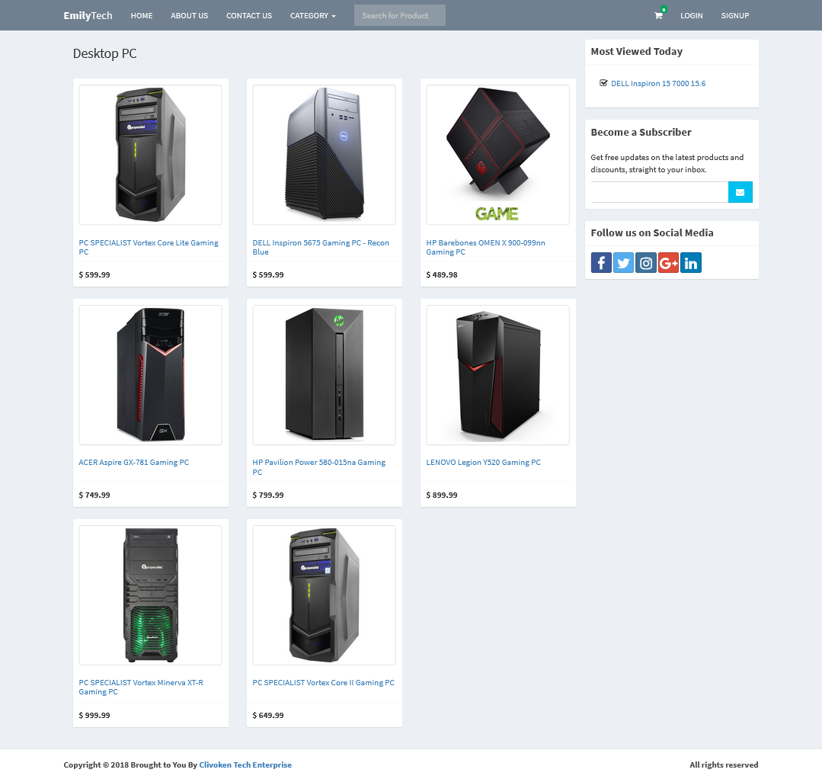
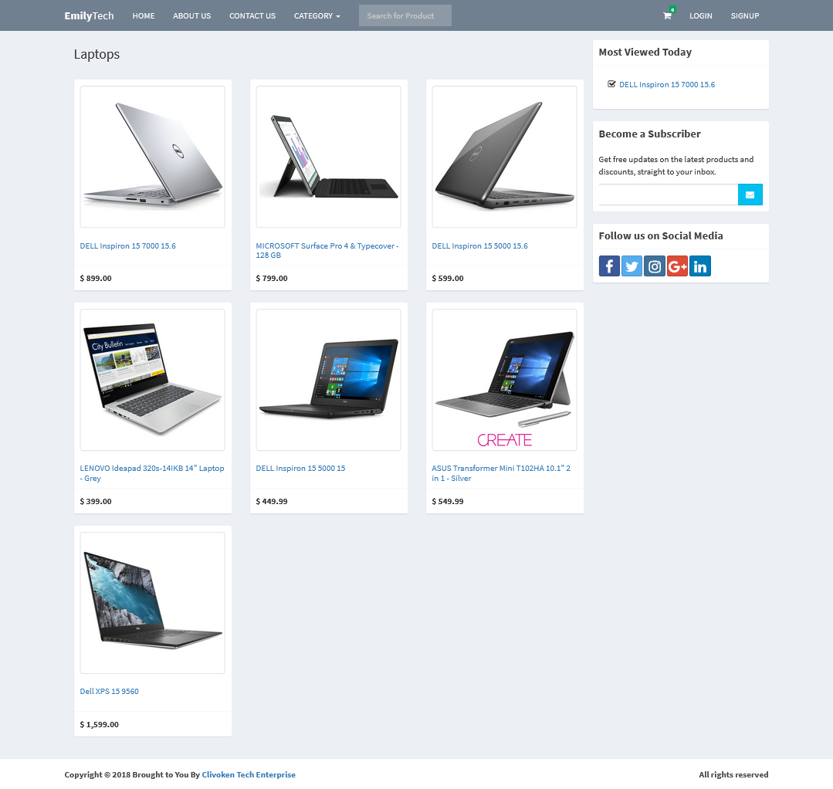

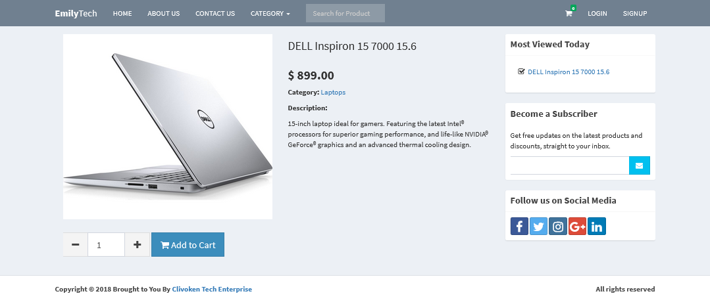
Technologies Used: HTML, CSS, JavaScript, jQuery, Tailwind CSS, PHP & MySQL
My Contributions: I started with the backend development. I created the MySQL database for the project with many tables that store the data of the site and maintain the inventory. using an MVC design model, I built the app logic and linked the database with the view (frontend). The app logic updates the database based on the purchases made by the users and the new stocks the client adds or removes.
A unique dashboard was built so that the client can manage the inventories.
Skills and Expertise:
- Proficient in HTML5, CSS3, and JavaScript
- Experienced in frontend frameworks such as React, Vue.js, Angular.js and NextJs
- Also strong in jQuery, Bootstrap CSS & JS and Tailwind CSS libraries
- Strong knowledge of responsive web design principles
- Backend development with proficiency in PHP, Python and NodeJS
- Well skilled in backend frameworks like Symfony (PHP), Laravel (PHP) and Django (Python)
- Proficient in content management systems (CMS) like WordPress, Wix, Webflow and others
- Familiarity with version control systems (Git) and other commandline development tools
- Ability to collaborate effectively with other developers and work as a team
- Excellent UI/UX designer and with skill in Figma, Adobe Photoshop and Adobe Xd
- Profound knowledge of Adobe Premiere Pro and Adobe After Effect for video editing
- Experienced graphics designer with specialty in Adobe Illustrator, Inkscape and Canva
- Excellent problem-solving and debugging skills
- Always ready to learn and improve
Testimonials:
Coker (FECAMDS vice president) - "Awwwn... This is very beautiful. Thank you! 🤗 ". She left me this message after creating the dinner ticketing platform for her association

